Line Lock Control Function – CGEA1.3

Functional Description

Line lock is a performance feature controlled by the AdvanceTrac stability control system that allows the vehicles front brakes to be applied while the rear brakes are free (no brake pressure) without driver brake input. This feature would be initiated by the driver and allow rear wheel spin while the front brakes are holding the vehicle stationary. Traditionally, line lock is used to heat the rear tires in the burnout box and keep the vehicle stationary at the staging beams.

The Line Lock feature would be initiated and engaged through the driver's interaction with the instrument cluster LCD display and five way selection button located on the steering wheel. The stability control module would control the feature and allow entry and exit, with the cluster utilizing a status signal transmitted by the ABS module to display the status of the feature to the driver. The stability control module is responsible for checking all pre-requisites pertaining to various states of the Line Lock feature. The cluster acts only as an interface module between the user and the AdvanceTrac system via various message center displays and the 5-way switch on the steering wheel.

The Line Lock Control Function correlates the BrkLineLck_D_Stat signal, the message center 5-way switches, the vehicle configuration, and the Operational_Mode to allow the driver to initiate and engage Line Lock via a sequence of message center displays.

Interfaces

Interface Context Diagram (I/O Block Diagram)

Figure 1: Line Lock Control Function Context Diagram
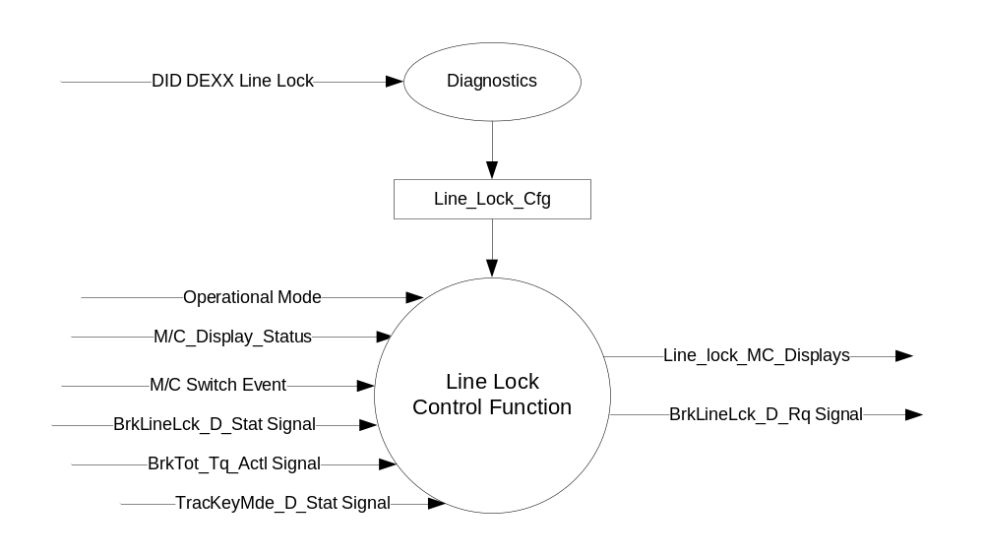

Inputs

- INTERNAL:
- Operational_Mode
- M/C_Display_Status
- M/C Switch Event
- Line_Lock_Cfg
- Current_Ign_Key_Dev_Type: Used to indicate the type of key currently in use in the vehicle. See MyKey Control Function STSS for further definition
- MUX signals on the CAN bus
- BrkLineLck_D_Stat Signal
Signal Name | Size  (bits) | Detail | Units | Res. | Offset | State  Encoded | Min | Max
BrkLineLck_D_Stat | 3 |  | SED | 1 | 0 |  | 0 (0x0) | 7 (0x7)
 |  | Available |  |  |  | 0x0
 |  | Initiated |  |  |  | 0x1
 |  | Engaged |  |  |  | 0x2
 |  | Off |  |  |  | 0x3
 |  | Not_Available |  |  |  | 0x4
 |  | Conditions Not Correct |  |  |  | 0x5
 |  | Unused |  |  |  | 0x6
 |  | Faulted |  |  |  | 0x7

- BrkTot_Tq_actl Signal
Signal Name | Size  (bits) | Detail | Units | Res. | Offset | State  Encoded | Min | Max
BrkTot_Tq_Actl | 13 |  | Nm | 4 | 0 |  | 0 (0x0) | 8189 (0x1FFD)
 |  | Unknown |  |  |  | 0x1FFE
 |  | Fault |  |  |  | 0x1FFF

- TracKeyMde_D_Stat Signal
Signal Name | Size (bits) | Detail | Units | Res. | Offset | State Encoded | Min | Max
TracKeyMde_D_Stat | 2 |  | SED | 1 | 0 |  | 0  (0x0) | 3  (0x3)
 |  | ModeNotDetermined |  |  |  | 0x0
 |  | Active |  |  |  | 0x1
 |  | NotActive |  |  |  | 0x2
 |  | NotUsed |  |  |  | 0x3

Outputs

- Line_Lock_MC_Displays
- MUX signals on the CAN bus

- BrkLineLck_D_Rq Signal
Signal Name | Size  (bits) | Detail | Units | Res. | Offset | State  Encoded | Min | Max
BrkLineLck_D_Rq | 2 |  | SED | 1 | 0 |  | 0 (0x0) | 3 (0x3)
 |  | No_Request |  |  |  | 0x0
 |  | Initiate |  |  |  | 0x1
 |  | Engage |  |  |  | 0x2
 |  | Off |  |  |  | 0x3

Function/Performance

Operational Modes

Mode | Differentiating Vehicle Conditions
Sleep Mode | Line Lock Control Function Inactive
Limited Mode | Line Lock Control Function Inactive
Normal Mode | Line Lock Control Function Active / Inactive
Crank Mode | Line Lock Control Function Active / Inactive

Voltage Levels

Refer to the Cluster Features Table located in the Operational Modes and Voltage Range Strategies of this SPSS.

Human-Machine Interface

Visual

Indicator Graphics / Display Format
For High End Display (SHMI), reference HMI Specifications:
Text: Program Master Warning Message List.xls | Program Translation Table.xls
Structure: Program Menu Structure.xls

Menu Structure:

LEVEL 0 (Main Menu) | LEVEL 1 | LEVEL 2
Track Apps | Line Lock | Line Lock displays
Note: Track Apps and and subsequent items within its menu are only displayed when Track Apps is configured as Enabled.
Line Lock and subsequent displays within the Line Lock system are only displayed if Line Lock is configured as Enabled.

Indicator Color Coordinates

Reference section COLOR & ILLUMINATION REQUIREMENTS (GRAPHICS)

Indicator Characteristics

Refer to Message Center X Display_Y Button Interface Section, where X and Y are appropriate values in this document.

Audio

None.

Switch Control Logic

Consumer access to the Line Lock Control Configuration shall be as specified in the Message Center Switch – 5 Button HW Interface –CGEA 1.3 and Message Center_SHMI Displays_5 Button Interface – CGEA1.3 STSS documents.

System Accuracy

Within a 100msec of receiving a message that results in a change of state the cluster will update the display to the proper status.

Operation: Performance and Functional

Subsystem Algorithm Flowchart / State Diagram

Figure 2: Line Lock Diagnostic Configuration Flowcharts

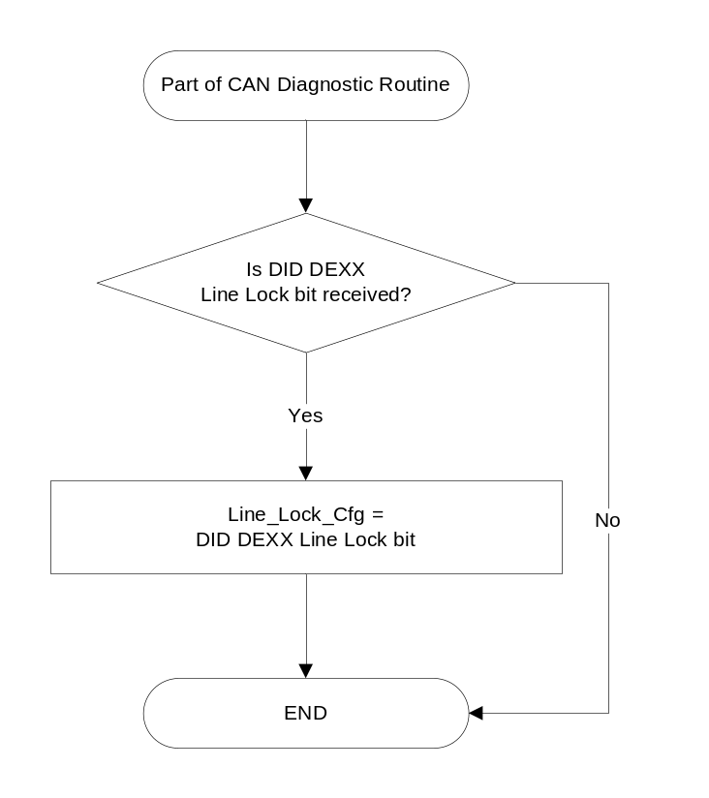

Figure 3: Line Lock Control Function
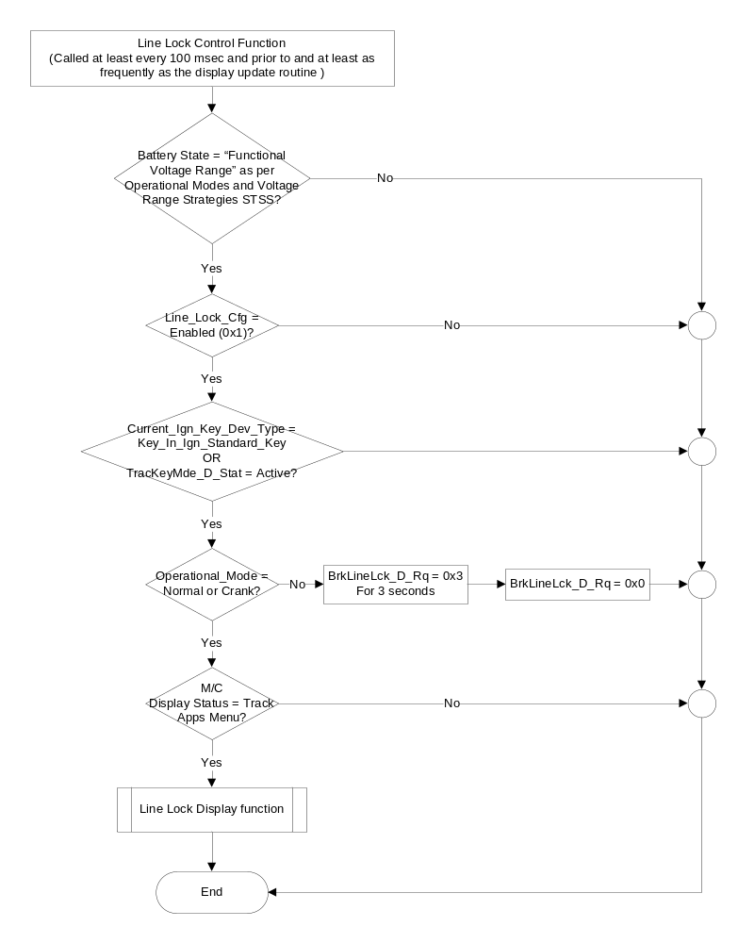

Figure 4: Line Lock Display Sub-Function

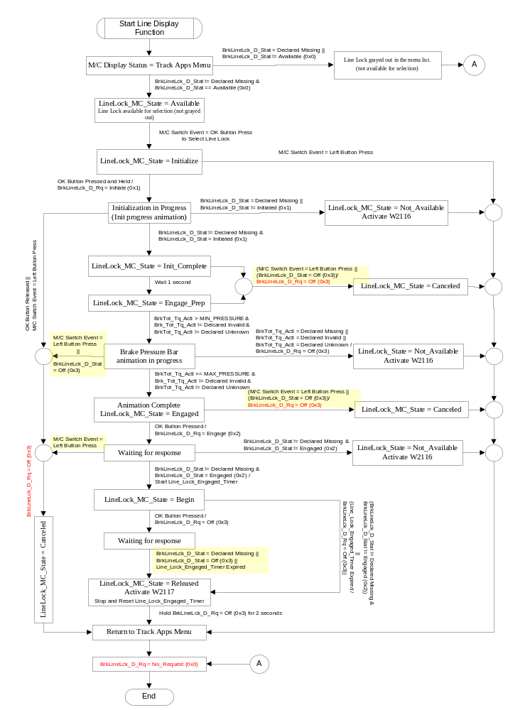

- Line Lock MC_Displays based on LineLock_Status
LineLock_MC_State | Line_Lock_MC_Displays  (example graphics)
Available | Track Apps menu with Line Lock available for selection (not grayed out)
Initialize | 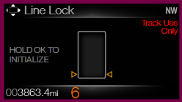
Init_Complete | 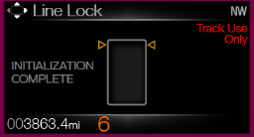
Engage_Prep | 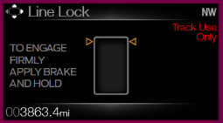
Engaged | 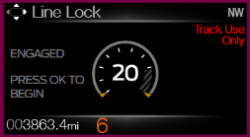
Begin | 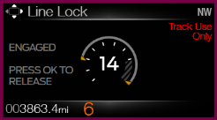
Released  W2117 | 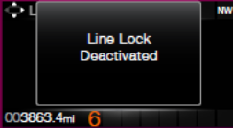
Canceled | 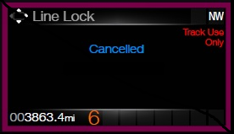
Not_Available  W2116 | 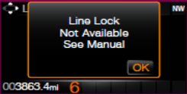

Init Progress Animation: While the user has pressed and held the OK button to initialize Line Lock, the “carrots” around the box shall start moving from bottom to the top and shall reach the top (as per graphics provided) at the end of Initialization period (2 seconds).

Brake Pressure Bar animation: Once the “Engage_Prep” state graphic is displayed, and the BrkTot_Tq_Actl > 0 Nm, the bars shall start filling up the box from bottom to top indicating increasing brake pressure. The bars are equally weighted based on the max value of the brake pressure. All the bars shall be filled up when BrkTot_Tq_Actl reaches MAX_PRESSURE value. (defined in section 1.3.5.4)

Operation Description (supports algorithm flowchart / state diagram)

- The Line Lock Control Function allows the driver to initiate, cancel, and engage/disengage the Line Lock feature through the message center via the 5-way switches.
- When in the Track Apps menu, if the cluster does not receive proper status as per figure 4 from the ABS module, the “Line Lock” item shall be grayed out. Only when cluster receives proper status from the ABS module as per figure 4 is “Line Lock” feature available to be engaged.
- The cluster is not responsible for checking any pre-conditions required to Initiate or Engage Line Lock. The ABS module is the controlling module and will do all the checks. It will then transmit appropriate status signals to which the cluster shall respond and change states on the display.
- Once selected, the user may cancel out of the feature while in the Initialization or Init_Complete states by pressing the Left button on the 5-way switch. While in the intilization screen, if the driver releases the OK button before the completion of 2 seconds, then the feature will also be canceled.
- The cluster shall continue to transmit the same value of the request until it changes.
- Once the cluster transmits the request signal, it shall wait 300 msec before reacting to the data received from the status signal to assure it (the cluster) does not respond to “old” data from the status signal.
- Once Line Lock timer has started, pressing of the Left, Right, Up or Down button will not have any effect on operation of the Line Lock feature.
- Once Line Lock is ON, the display shall remain active until either a) the user deactivates Line Lock by pressing OK and receiving appropriate status in return or b) Line_Lock_Engaged_Timer expires.
- The Line_Lock_Engaged_Timer shall have a value that can be configured via a supplier DID with initial value as per section 1.3.5.4.
- The maximum value of brake pressure used in the brake pressure bar animation (MAX_PRESSURE) shall be configurable to different values via a supplier DID with initial value as per section 1.3.5.4.
- If the cluster does not receive appropriate status (includes missing signal) to the user’s request to deactivate Line Lock, the cluster shall force the Deactivate once the Line_Lock_Engaged_Timer has expired. The cluster shall turn Line Lock Off and return to the Track Apps menu as per figure 4.
- The Line Lock feature shall not be available if Line_Lock_Cfg is set to disabled (0x0).

Function Safety Classification (EMC)

B

Memory Storage

Parameter Name | Description | Value at Battery connect | Value at  Module Wake-up
M/C_Display_Status | Input to this routine that is a State Indicator to identify which text is currently being displayed on Message Center display. | See Message Center_SHMI Displays_5 Button Interface STSS | See Message Center_SHMI Displays_5 Button Interface STSS
M/C Switch Event | Event that is indicated as per the switch interface for the Message Center. See * | See * below | See * below
Line_Lock_Cfg | State Indicator for feature presence controlled via CAN at EOL at VO plant. Defaulted to Disabled at supplier manufacturing | Use Stored Value | Use Stored Value
LineLock_MC_State | Internal variable to the cluster to determine the Line Lock state and activate proper display screens. | Available | Available
BrkLineLck_D_Stat | Input CAN signal | 0x0 (Available) | 0x0 (Available)
BrkLineLck_D_Rq | Output CAN signal transmitted by the cluster. | 0x0 (No Request) | 0x0 (No Request)
BrkTot_Tq_Actl | Input CAN signal from ABS indicating brake pressure. | 0 (0x0) Nm | 0 (0x0) Nm
TracKeyMde_D_Stat signal | Input from BCM providing status of TracKey | ModeNotDetermined (0x0) | ModeNotDetermined  (0x0)
Operational_Mode | Input to this routine that is a 4 State indicator for cluster operational mode | Limited | Limited, Crank or Normal
* Refer to Message Center X Display Y Button Interface Section, where X and Y are appropriate values in this document.
Parameter Name | Description | Range | Units | Res | Init Value
Line_Lock_Engaged_Timer | Countdown Timer to keep Line Lock engaged if user does not choose to deactivate it. | 0-20 | sec | 0.1 | 15 sec

Parameter Name | Description | Range | Units | Offset | Res | Init value
MIN_PRESSURE | Minimum brake pressure required to start brake pressure bar animation | 0 –8189 | Nm | 0 | 4 | 0 Nm
MAX_PRESSURE | Max brake pressure value required to fill up all the “bars” in the animation. Max pressure is used to calculate value required for each “bar”. | 0 – 32756 | Nm | 0 | 4 | 8800 (0x0898) Nm  (Tunable value thru a supplier DID: Line_Lock_Max_  Brake_Pressure)

Prove Out

No

Reconfigurable Telltale

No

Message Center Msg

Reference displays in section 1.3.5.1 and W2116 and W2117 as per the Global message list.

Error Handling

Missing Message Strategy

The signals will be declared missing as per the Diagnostics section of this SPSS.

DTCs states and history will be determined as per the Diagnostics section of this SPSS.

If Line_Lock_Cfg is Disabled (0x0), DTC shall never be logged for this feature.

Diagnostics

Self Test

None

Engineering Test Mode

None

Part II Performance

Supported Diagnostic DIDs (Service $22 and $2E)
Number | DID / Common ID Name | DID Type | Comments / Information
$FDXX | Line_Lock_Engaged_Timer | Numeric | DID used to change the line lock engage timer value.
$FDXY | Line_Lock_Max_Brake_Pressure | Numeric | DID used to change the max value of brake pressure used in the “brake pressure bar animation”.

Supported Diagnostic Trouble Codes (DTCs)

DTC | Description
C12100 | Lost Communication with ABS_ESC

DID DEXX

Block  Num | Block Description | Byte(s) | Bits | State: Description | "0" | "1" | Default | Comments/ Information
PACKETED BLOCKS
$XX | Option Content (B&A) | * | * | Line Lock | Disable | Enable | Disable

Reference Specification

- Func. Criticality EC-0048
- Oper. Voltage Func. IS-0053
- Glare/Reflections 16-0068
- Harmony: Graphics / Font / Ill. 17-0040
- Ergo - Access. 17-0052
- Ergo - Operablility 17-0053
- Control & Display Loc. 17-0060
- Logical grouping Function and Usage 17-0062
- Assoc. of Controls with Disp. & elem. 17-0063
- Ill. Controls & Disp. 17-0074
- Id. Legibility 17-0081
- Logic of Op. 17-0120
- Interpretation 17-0122
- Feedback 17-0124

Revision History

SPSS Module Revision History
Revision Level | Name | Change Description | Date
1.0 | V. Patel | Initial Release | 2/9/2013
1.1 | V. Patel | - Section 1.2.3: Changed the size of the output signal BrkLineLck_D_Rq to 2 bits based on change made by feature owner (Scott Mlynarczyk).  - Seciton 1.3.5.1:  - Figure 4: Modified table to reflect changes in the output signal being consolidated to 2 bits. (Updates in red)  - Removed note b) below table 1.2. “Completed” graphic does not need to be displayed once the “Canceled” progress bar has completely filled up.  - Added statement below the example graphic to wait an additional 2 seconds before progressing to the next graphic after displaying “Complete”.  - Section 1.3.5.2: Added requirements in red for clarification purposes. | 4/1/2013
1.2 | V. Patel | - Section 1.3.5.1, figure 4: Modified figure to add new studio approved state of displaying brake pressure indicator between “Initialize” and “Engage”. Added a new LineLock_MC_State state “Begin”, which activates Linelock. “Engage” is now a part of Linelock preparatory process.  - Section 1.2.1, figure 1: Added “BrkTot_Tq_Actl” input signal required to display Linelock “Engage” animation.  - Section 1.2.2, table 1.2: Added new table to show detail of the “BrkTot_Tq_Actl” input signal.  - Section 1.3.5.1, figure 4: Added path to Cancel LineLock if input conditions are not fulfilled or if Left button is pressed while in “Engaged” state.  - Section 1.3.5.1, table 1.3: Updated table to add the new and modified states as per figure 4, and changed example graphics based on new graphics provided and approved by studio.  - Section 1.3.5.2: Added requirement to make Line_Lock_Engaged_Timer to have a configurable value. (update in blue text.)  - Removed 2 second progress bar associated with the Line Lock “Canceled” state as per direction from S. Dionyssopoulos. This makes it consistent with other features that have the Canceled state. Updated example graphic in table 1.2 to reflect this change.  - Section 1.3.5.1, figure 3: Added requirement to transmit 0x3 for 3 seconds followed by 0x0 on the BrkLineLck_D_Rq if ignition transitions to Off/Acc during the Line Lock process as per direction provided by feature owner (S. Mlynarczyk) dated 6/6/2013  - Section 1.3.5.1, figure 3: Removed “Track_Apps_Cfg” config flag since it is not required anymore. Added decision block to check for MyKey ignition key type. | 7/12/2013
1.3 | V. Patel | No change in functionality of the feature, this version includes some missing information regarding the brake pressure indication values.  - Section 1.3.5.1, figure 4, table 1.3: Added information regarding the values used to drive the brake pressure bar animation to engage Line Lock.  - Section 1.3.5.1, figure 4: Added a 1 second delay between the end of the “Init_Complete” graphic and beginning of the “Engage_Prep” graphic.  - Section 1.3.5.4: Added table to define the MIN_PRESSURE and MAX_PRESSURE used to drive the brake pressure bar animation.  - Section 1.5.3: Added a table to defined supplier DIDs used to fine tune the values of Line Lock Timer and MAX_PRESSURE. | 8/8/2014
1.4 | V. Patel | This update fixes a couple of minor issues found by the supplier during implementation.  - Section 1.3.5.1, figure 4: Removed transmitting of 0x3 if user presses Left button to exit “Initialize” state before the initializing sequence begins.  - Section 1.3.5.1, figure 4: Created a path from the “Begin” state to W2117 (Line Lock Released) to capture the requirement of 15 second timer getting expired before the user presses OK to cancel/end Line Lock.  - Section 1.3.5.1, figure 4: Added a path from the “Engaged” state to W2116 (Line Lock Unavailable) if the ABS module does not send appropriate status for the request to “Engage” Line Lock. (This issue was found during functional testing.) | 10/14/2013
1.5 | V. Patel | The purpose of this update was to activate the “Line Lock Released” warning if ABS malfunctions after Line Lock has begun (Direction from feature owner: Scott Mlynarczyk)  - Section 1.3.5.1, figure 4:  - Added check for “BrkLineLck_D_Stat <> 0x2) in the path going from Line Lock “Begin” state to “Released” state.  - Also added condition to hold BrkLineLck_D_Rq = 0x3 for 2 seconds after Line Lock has been released, before the display is reverted back to Track Apps menu. This is to prevent the Line Lock from reengaging again accidently.  - Section 1.3.5.4: Updated memory storage table to fix name of CAN signals.  - Section 1.3.5.4: Changed the resolution of MIN_PRESSURE and MAX_PRESSURE from 4 to 1. (4 was incorrect and caused issues). | 1/30/2014
1.6 | V. Patel | Purpose of this update is to clear up some concerns addressed by the supplier that arose during vehicle level testing. Supplier has already implemented the fixes, the STSS update is to get aligned with implementation.  - Section 1.3.5.1, figure 4: Added a couple of checks for BrkLineLck_D_Stat = 0x3 (Off) to ensure cluster does exits out of Line Lock. Updates are highlighted in yellow.  - Section 1.3.5.4: Changed the resolution of MIN_PRESSURE and MAX_PRESSURE from 1 to 4 since the range needs to be increased for higher brake pressure. | 2/13/2014
1.7 | V. Patel | Purpose of this version is to update the value of the max brake pressure required to engage Line Lock. There is no change in functionality. The value of the max brake pressure is controlled by a supplier DID.  Section 1.3.5.4: Changed value of MAX_PRESSURE to 8800 Nm (0x898) | 4/23/2014
1.8 | V. Patel | Update to clarify supplier question regarding the input to be used to determine if TracKey is active for this feature. Since it is a CAN input from BCM, the spec is updated to define it explicitly. There is no change to the functionality of the feature.  - Section 1.2.1, figure 1: Added the TracKeyMde_D_Stat Signal as an input.  - Section 1.3.5.1 Figure 3: Updated the diamond that checks for type of key used. Replaced the use of MyKey with Standard Key and TracKey inputs.  - Section 1.3.5.4: Added the TracKeyMde_D_Stat Signal as an input. | 4/27/2015

